Name: MITHUN MARAGIRI

Course: EE450

Session #: 2

Assignment: OPNET OSPF

**ABSTRACT**

The purpose of this report is to discuss the laboratory assignment for the course EE-450 Introduction to Computer Networks. The assignment is to simulate OSPF (Open Shortest Path First) environment with real-time networks and protocols. The labs have been deployed in Riverbed Modeler Academic simulation environment. The simulation in this lab will help examine the performance of OSPF for displaying routes taken by the routers.

The assignment consists of simulation of 3 scenarios: No_Areas, Areas and Balanced. The analysis of the experiment results are done for a simulation time of 10 minutes.

**INTRODUCTION**

Riverbed Modeler Academic Edition offers all the tools for network model design, simulation and analysis of the experiment results. Riverbed Modeler can simulate a wide variety of different networks. The laboratory has been designed to simulate Routing Information Protocol. Through this lab, we get to learn how to use Rapid Configuration Tool for setting up topology with 8 routers and each interconnected. The different options available while setting up a network, the simulation parameters, comparing the results from different scenarios, the design of network simulation for performance evaluation.

**GRAPHS**

* **No_Areas Scenario: Display route between Router A and Router C.**

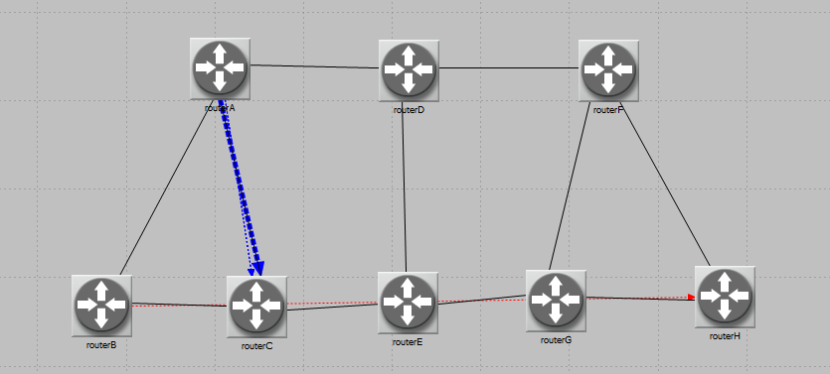

* **No_Areas scenarios. Display route between Router B and Router H**

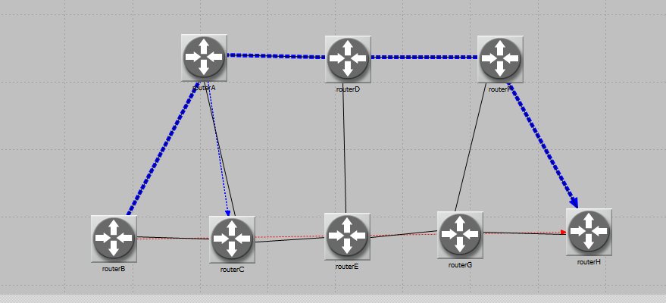

* **Areas Scenario: Display route between Router A and Router C**

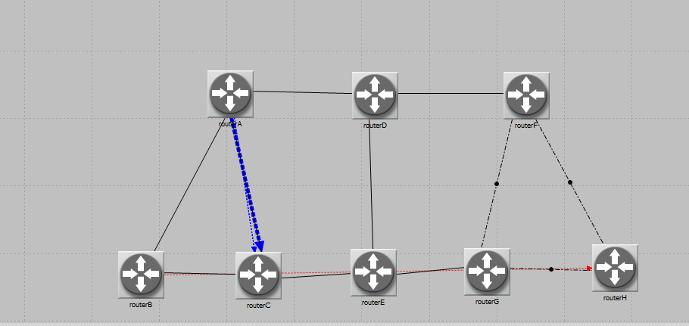

* **Balanced Scenario: Display route between Router B and Router H**

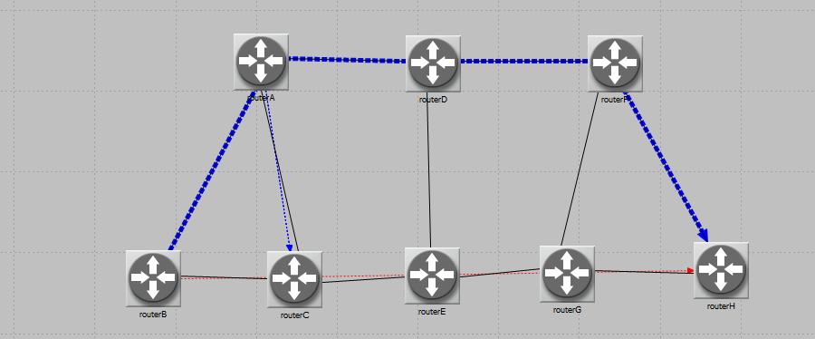

**EXERCISE**

1. Explain why, for the same pair of routers, the Areas and Balanced scenarios result in different routes than those observed in the No_Areas scenario.

Ans: the balanced scenario does not split the traffic over two paths because of some unknown internal default configuration of the new version of Opnet.

1. Using the simulation log, examine the generated routing table in RouterA for each one of

the three scenarios. Explain the values assigned to the Metric column of each route

Ans: No_Areas Scenario

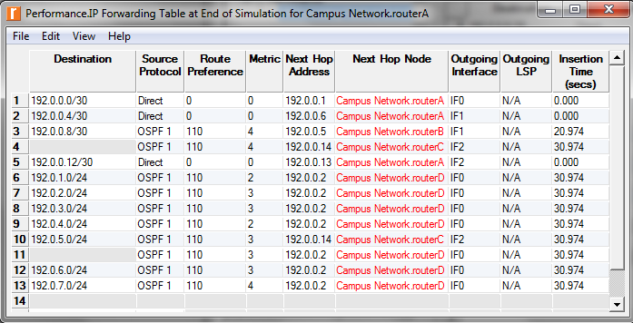

Areas Scenario

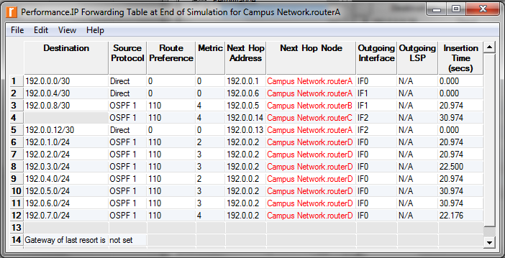

Balanced Scenario

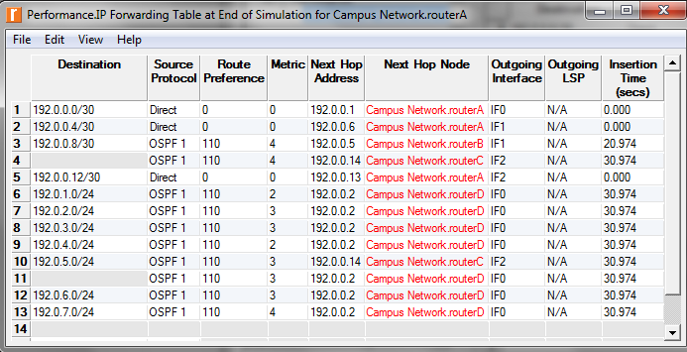

When we observe the tables both No_Area and Balanced are having same tables but they are different in Area scenario. And this occurs by some reasons like no traffic in between A and C and the area identifier ,the path will pass as per the identifier and table will be different .

1. OPNET allows you to examine the link-state database that is used by each router to build the directed graph of the network. Examine this database for RouterA in the No_Areas scenario. Show how RouterA utilizes this database to create a map for the topology of the network, and draw this map

Ans: No_Areas Scenario, Link State database.

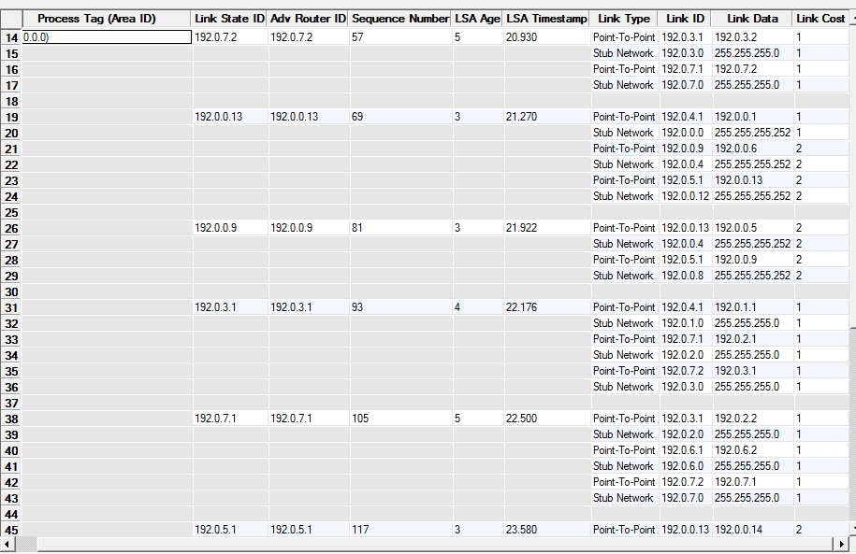  
The link state data base is used to create map for the topology.

1. Create another scenario as a duplicate of the No_Areas scenario. Name the new scenario

Q4_No_Areas_Failure . In this new scenario, simulate a failure of the link connecting RouterD and RotuerE . Have this failure start after 100 s. Rerun the simulation. Show how that link failure affects the content of the link-state database and routing table of RouterA . (You will need to disable the global attribute OSPF Sim Effi ciency . This will allow OSPF to update the routing table if there is any change in the network.)

Ans:

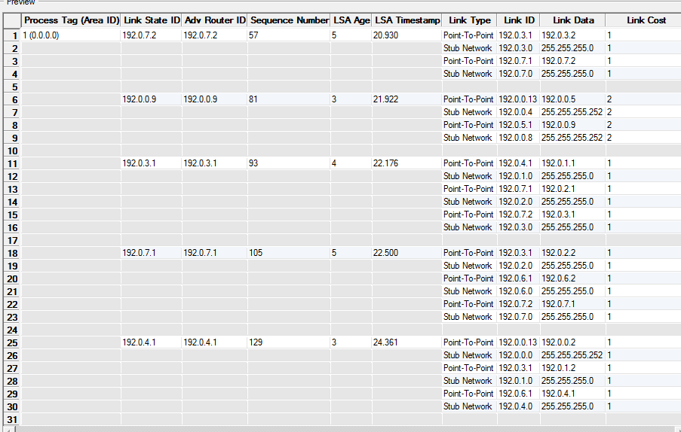

Forwarding Table entry 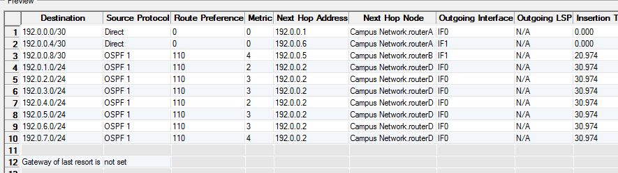

1. For both No_Areas and Q4_No_Areas_Failure scenarios, collect the Traffi c Sent (bits/sec) statistic (one of the Global Statistics under OSPF ). Rerun the simulation for these two scenarios and obtain the graph that compares the OSPF’s Traffi c Sent (bits/sec) in both scenarios. Comment on the obtained graph.

Ans:

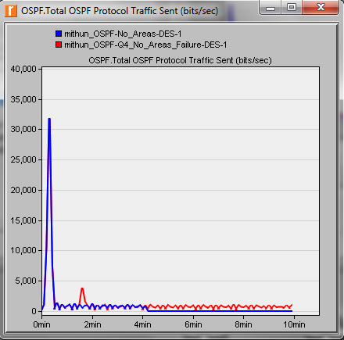

The fail link between D and E router and they will increase the traffic and this is why the traffic is more in Q4_No_Areas_Failure scenario than in No_Areas.

**RESULTS**

We have studied the 3 cases: No_Areas, Areas, Balanced. After this lab i got the introduction for OSPF protocol. And the knowledge of dealing the routing table and making out the difference between them.

**Riverbed Modeler Experience**

The tool is very much user friendly and has easy to use graphical user interface. The assignment description document has detailed explanation about the configuration and the procedure for conducting the lab. The usage to the tool gave an understanding of how to simulate OSPF, the various components needed to setup the topology, the performance measures for each of these scenarios. The installation of the tool is also very simple and straightforward. The tool is scalable to great extent. If we want to update the network scenario we can do it without rebuilding entire thing from scratch. OPNET modeller lets us analyze realistic simulated networks to compare the impact of different technology designs on end to end behaviour.